Nivelamento Basic 1

1. **Complete the conversation. Use the words in the box. Use capital letters when necessary.**

are I’m it’s ‘s we’re what’s

Lisa: Hey, Steve, this is my friend Adam. Adam ‘s from Vancouver. Steve: Hi, Adam. So, um, are you here on vacation?

Adam: No, I’m a student. Steve: Oh, really?

Adam: Yeah. I start classes on Friday. Steve: What’s your first class?

Adam: Uh, I have French with Mr. Cass on Friday.

Steve: Hey, I have French with Mr. Cass on Friday. we’re in the same class. Adam: That’s great.

Steve: Yeah… So, what’s Vancouver like?

Adam: Vancouver? I think it’s a really fun city. Really beautiful. Steve: Uh-huh…

# Circle the correct words:

* 1. A: ***I’m / My*** a Yankees fan.

B: Really? ***They’re/ Their*** my favorite team.

* 1. A: ***We’re / Our*** grandparents are from Canada.

B: Really? ***I’m / My*** mother is from Canada.

* 1. A: What’s ***your / you’re*** brother’s name?

B: ***He’s / His*** name is Ray.

# Match the questions with the answers. Use each answer only once.

* 1. What’s your phone number? F
  2. What’s your e-mail address? A
  3. Where are you from? H
  4. How old are you? C
  5. What are your parents like? D
  6. Who’s he? G
  7. Is this your computer bag? B

1. It’s [ejones17@cup.org](mailto:ejones17@cup.org)
2. Yes, it is.
3. I’m 16.
4. They’re really nice.
5. I think they’re pens. f. It’s 555-4448
6. He’s my brother.
7. What are these? E h. I’m from Los Angeles.
8. **Look at the picture. Complete the answers with:** *next to / on / in / under***. (1 each)**

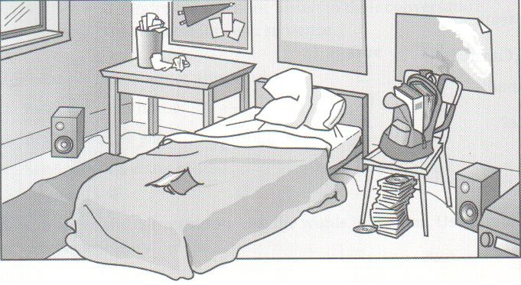

* 1. A: Where’s the wastebasket? c. A: Where are the CDs?

B: It’s on the table. B: They’re under the chair.

* 1. A: Where’s the table? d. A: Where are the books?

B: It’s next to the bed. B: They’re in the backpack.

1. **Complete the conversation. Write *Me too* or *Me neither*. (0,5 each)**

*Jessica*: I think Johnny Depp is so good-looking.

*Marisa*: me too . And he’s an amazing actor.

*Jessica*: Yeah. I like his movie *Pirates of the Caribbean*.

*Marisa*: me too . But you know, I don’t go to the movies a lot these days.

*Jessica*: me neither . They’re so expensive.

*Jessica*: I know! These days, I just rent DVD.

*Marisa*: me too .

# Read each sentence. Circle the correct words. (0,5 each)

* 1. I don’t like coffee.

I **always/ usually/ never** drink coffee.

* 1. My sister plays soccer every day after school.

She **often / hardly ever / never** plays soccer.

* 1. My dad goes on the Internet about once a month.
  2. He **always / often / hardly ever** goes on the Internet.
  3. My best friend goes to a club every Saturday.

She **always / sometimes / hardly ever** goes to a club on Saturday.

# Complete the sentences. Write *There is* or *There are* and choose one of the two options between slashes. (1 each)

* 1. *There are*  **no/a** nice stores in my neighborhood.
  2. *There is*  **a / a couple of** pool near my house.
  3. *There are*  **some / a** cafés near the park.

1. *There is* **no / a lot of** cafeteria in my office building.
2. *There is* **a / some** big school around here.

# Read each sentence. Circle the correct word. (1 each)

* 1. On Monday afternoon, Erika **takes / goes / does** a computer class.
  2. On weekends, Rick **plays / makes / goes** soccer.
  3. In her free time, Mari **goes / makes / takes** shopping.
  4. I **do / make / have** phone calls in the evening.
  5. He **drives / has / watches** breakfast in the morning.